Wet Standard (Sb/Sb)
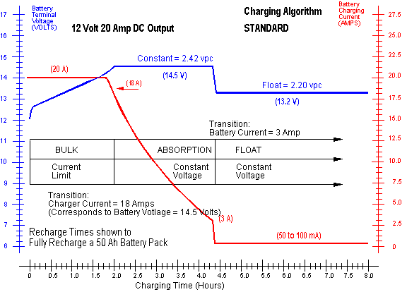

Wet Low Maintenance (Sb/Ca)
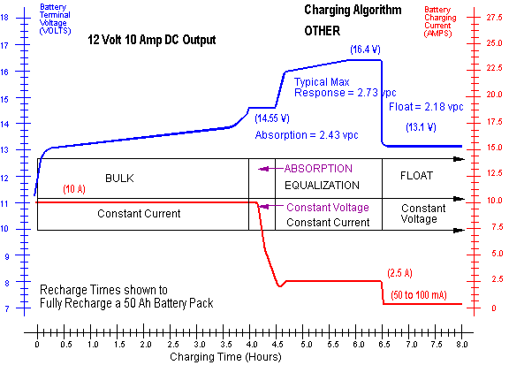

Wet "Maintenance Free" (Ca/Ca)
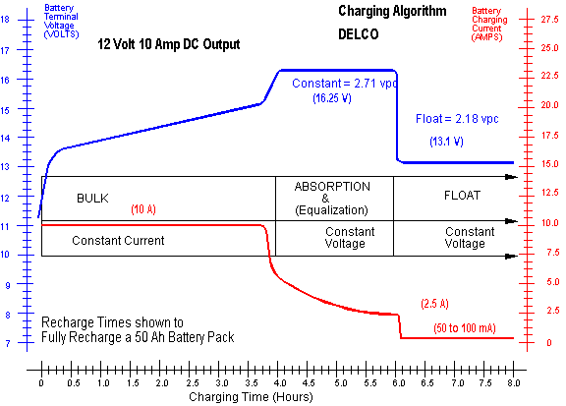

Absorbed Glass Mat [AGM] VRLA
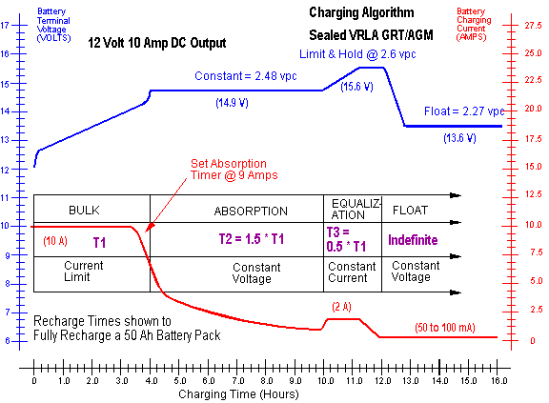

Gel Cell VRLA
